Project Overview

The Online Food Truck Ordering System is a platform designed to facilitate a seamless and convenient food ordering experience for users from various food trucks. The system allows users to browse through available food trucks and their menus, place orders, and track the status of their orders. The platform also provides food truck owners with tools to manage their schedules, menus, employees, and track the performance of their business.

The system includes multiple entities such as users, managers, employees, food trucks, food truck schedules, items, item orders, and orders. Users can sign up on the platform with their unique ID, first name, last name, password, and email. Food trucks are managed by managers and employees, and each truck has a unique ID, name, description, image, location, items, and schedules.

The platform utilizes a well-designed database schema to manage relationships between entities and ensure data consistency and integrity. The schema includes foreign keys to establish relationships between entities, such as the relationship between a manager or employee and a food truck, or between a food truck and its items. The schema also enforces constraints to maintain data integrity, such as unique constraints on email and IDs, and cascading deletes and updates to ensure data is properly maintained across related entities.

In conclusion, the Online Food Truck Ordering System aims to provide a comprehensive platform for customers to place orders and food truck owners to manage their businesses. The platform streamlines the ordering process, making it easy for users to find and order from their favorite food trucks, and empowers food truck owners to efficiently manage their schedules, menus, and employees.

Database Structure

The Online Food Truck Ordering System's database consists of multiple tables designed to store and manage essential data related to users, food trucks, schedules, items, and orders. The main tables in the database are the "user", "food_truck", "food_truck_schedule", "item", "order", and "item_order" tables, which are interconnected through foreign keys.

DATABASE TABLE | DESCRIPTION
user | Contains information about users, including their unique ID, first name, last name, password, and email.
manager_employee | Stores details about managers and employees, such as their unique ID, first name, last name, password, email, and a foreign key referencing the food_truck table.
food_truck | Holds information about food trucks, including the unique ID, name, description, image, location, and foreign keys referencing the manager and employee tables
food_truck_schedule | Manages schedules for each food truck, containing the unique ID, day, start time, end time, location, food truck ID, and orders.
item | Contains data about food items, such as the unique ID, name, price, quantity, image, category, description, and a foreign key referencing the food_truck table.
order | Stores information about orders placed by users, including the unique ID, creation date and time, total amount, pickup time, food truck schedule ID, user ID, and item orders.
item_order | Manages the relationship between items and orders, containing the unique ID, quantity, price, creation date and time, item ID, and order ID.

This structure allows the Online Food Truck Ordering System to efficiently manage the user experience, food truck schedules, menus, and ordering process while providing a seamless experience for customers and food truck owners alike.

Functionality

The Online Food Truck Ordering System database and web application enable various stakeholders, such as customers, food truck owners, managers, and employees, to perform the following functions:

• Browse and order food items from available food trucks
• View and update food truck menus and schedules
• Manage food truck registration and employee assignments
• Track orders, pickups, and order status in real-time
• Handle order cancellations and modifications (if applicable)
The Online Food Truck Ordering System database is password-protected, requiring a login for managers, employees, and users to ensure data security and maintain privacy. Session control features are also in place to automatically log out users if their session remains idle for an extended period, further enhancing security.

In addition to the core functions listed above, the Online Food Truck Ordering System application and database provide advanced capabilities for food truck owners, managers, and employees to:
• Monitor and manage the performance of their food trucks, schedules, and menus
• Generate reports based on various criteria, such as sales history, revenue, and customer preferences

These additional features empower food truck owners and managers to make informed decisions about their operations and resource allocation, leading to increased efficiency and overall success within the platform.

Customer Audience

The primary users of the Online Food Truck Ordering System platform are customers, food truck owners, managers, and employees. These users can be categorized into four main groups:

1. Customers: Customers use the Online Food Truck Ordering System to browse and order food from various food trucks based on their schedules and locations. They can track their orders, view food truck menus, and interact with the platform using their unique user IDs. This user-friendly platform simplifies the food ordering process and provides a convenient way for customers to enjoy their favorite food trucks.

2. Food Truck Owners: Food truck owners are responsible for managing their food trucks on the platform, including registering their trucks, updating menus and schedules, and assigning managers and employees. They can also monitor their trucks' performance, generate reports, and make informed decisions about their operations and resource allocation.

3. Managers: Managers play a crucial role in the Online Food Truck Ordering System by overseeing the daily operations of their assigned food trucks. They can update food truck menus, manage schedules, and monitor employee performance. Managers are also responsible for ensuring a smooth customer experience and maintaining high levels of service quality.

4. Employees: Employees work at the food trucks, preparing and serving food to customers. They can access the platform to view their assigned food truck's schedule, menu, and other essential information. Employees also play a vital role in ensuring customer satisfaction and maintaining the overall efficiency of the food truck's operations.

The Online Food Truck Ordering System aims to simplify and streamline the food truck ordering experience for all users, regardless of their role within the platform. By providing a comprehensive, web-enabled platform, the Online Food Truck Ordering System not only increases efficiency in the ordering process but also empowers users to access crucial information and make informed decisions.

Database Design Process

The basic approach for the Online Food Truck Ordering System database project was to develop an efficient and scalable database design that would meet the requirements and goals of the platform. The following steps were taken to achieve this:

1. Planning, design, and review: We began by conducting thorough planning and design sessions, reviewing the requirements, and identifying essential components for the Online Food Truck Ordering System database. This initial phase helped establish a solid foundation for the project.

2. Technical consultation: We consulted with experienced database administrators (DBAs) and developers to ensure that the chosen technologies (such as SQL, PHP, or JSP) were suitable for the Online Food Truck Ordering System and would meet its performance and scalability needs.

3. Database design and optimization: We designed and optimized the Online Food Truck Ordering System database, creating tables and relationships between entities that provided flexibility for future growth and changes. This step allowed us to create a robust and efficient database structure.

4. Code integration and improvement: We integrated the Online Food Truck Ordering System application code with the new database tables, improving the layout, functionality, and overall user experience. We used object-oriented programming principles and techniques like 'include' statements in PHP to promote code reusability and maintainability.

5. Lessons learned: Throughout the design process, we learned several important lessons, including the critical importance of table design, the challenges of revising existing databases and applications, and the need to understand clients' business processes and requirements.

By following these steps, we successfully designed and developed a database and web application for the Online Food Truck Ordering System that met the platform's needs, offered flexibility for future growth, and delivered a user-friendly interface for managing food truck orders and related tasks.

Future of the Database

The Online Food Truck Ordering System database is currently functional as a stand-alone web application, providing a robust and user-friendly solution for managing food truck orders and related tasks. However, the ideal situation would be for the database to be seamlessly integrated into other relevant systems, making it a fully supported production application that requires minimal maintenance.

To achieve this, several tasks have been identified for future development:

1. Gather feedback (both direct and observational) from users, including customers, food truck owners, managers, and employees, on feature set and usability requirements for the Online Food Truck Ordering System application.
2. Develop information architecture for needed forms, web pages, and database tables to support the application.
3. Optimize the database structure and implement any required changes or updates.
4. Code web pages using appropriate frameworks to interact with the back-end and the database tables.
5. Conduct usability testing of the completed pages with users and develop a punch list of improvements and fixes needed.
6. Update code to incorporate feedback noted in step #5 above.
7. Document and hand off the codebase for production implementation by the relevant teams.

By following this plan, the Online Food Truck Ordering System can evolve into a fully integrated and supported application that streamlines food truck ordering and provides a satisfying experience for all users.

Summary

This project has been a valuable learning experience, allowing us to enhance our skills in SQL, back-end programming languages, front-end frameworks, and HTML. We have developed a usable and efficient application for managing food truck orders and are proud of the results of our efforts. We eagerly anticipate the successful implementation of the Online Food Truck Ordering System soon, providing users with an effective and convenient tool for managing food truck orders and related tasks.

Screenshots

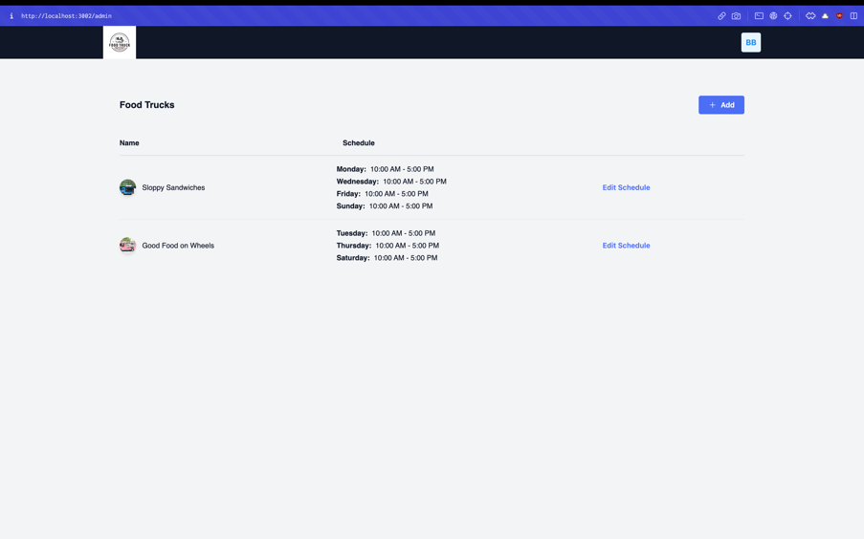

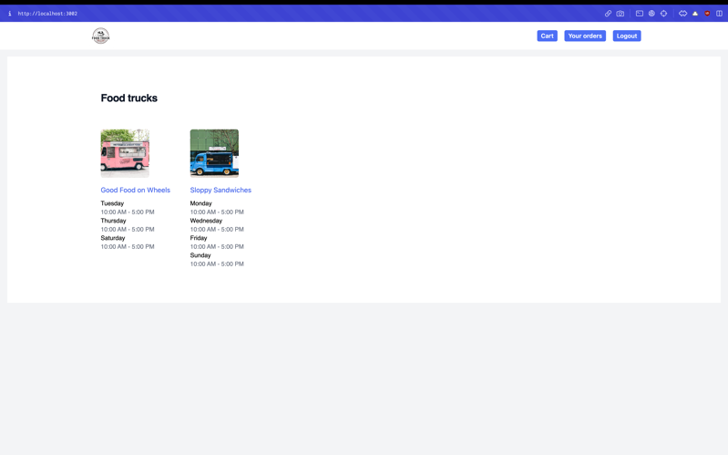

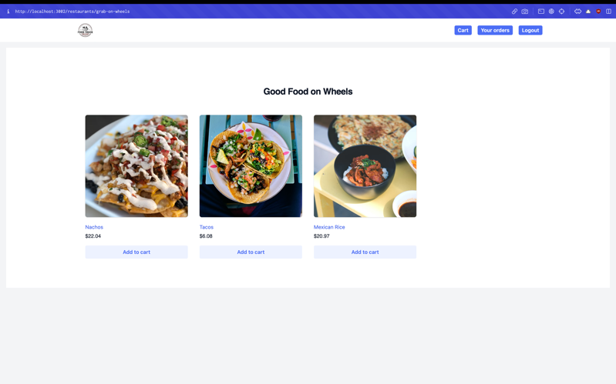

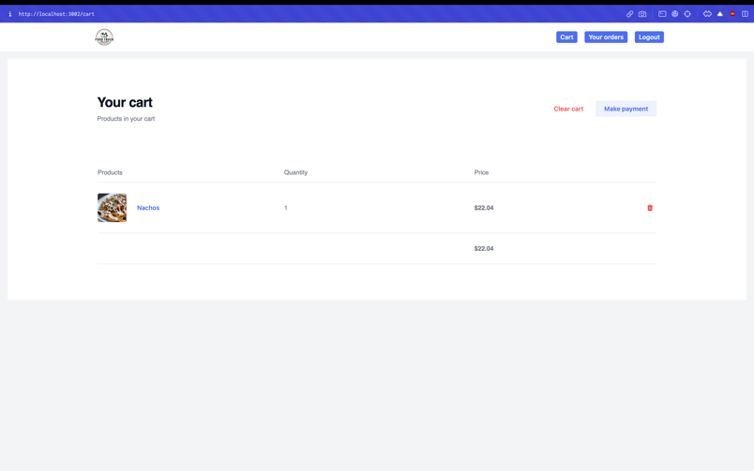

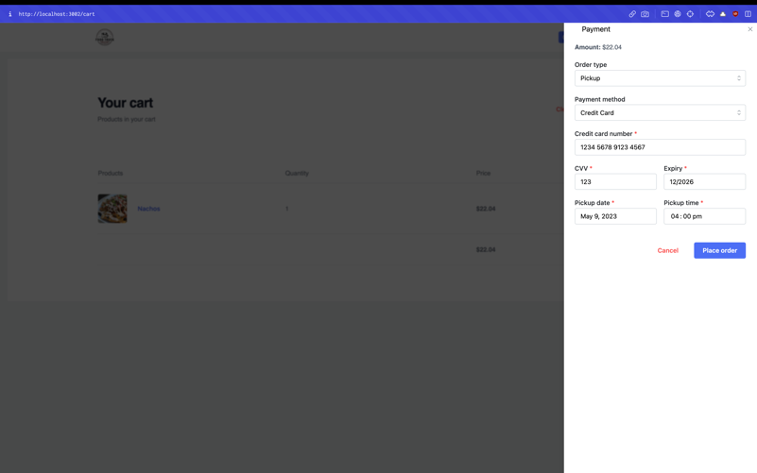

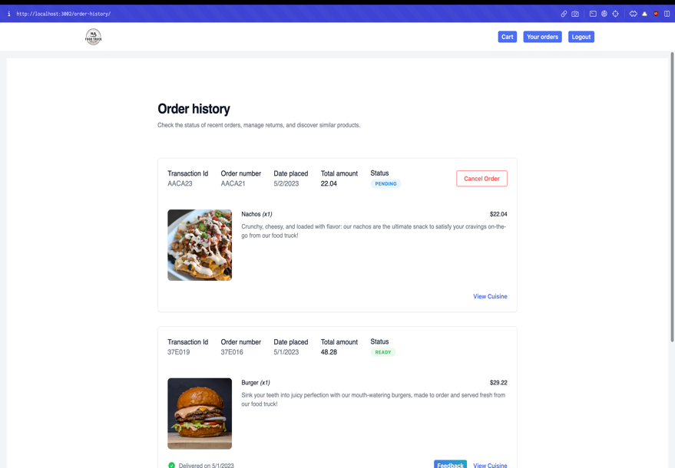
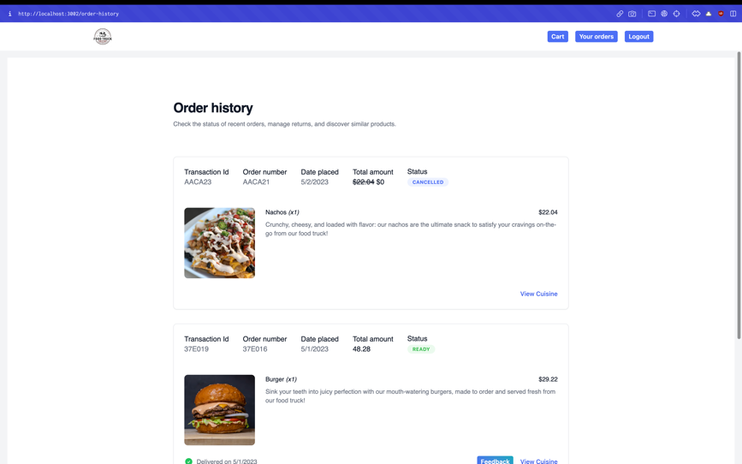

EMR Diagram

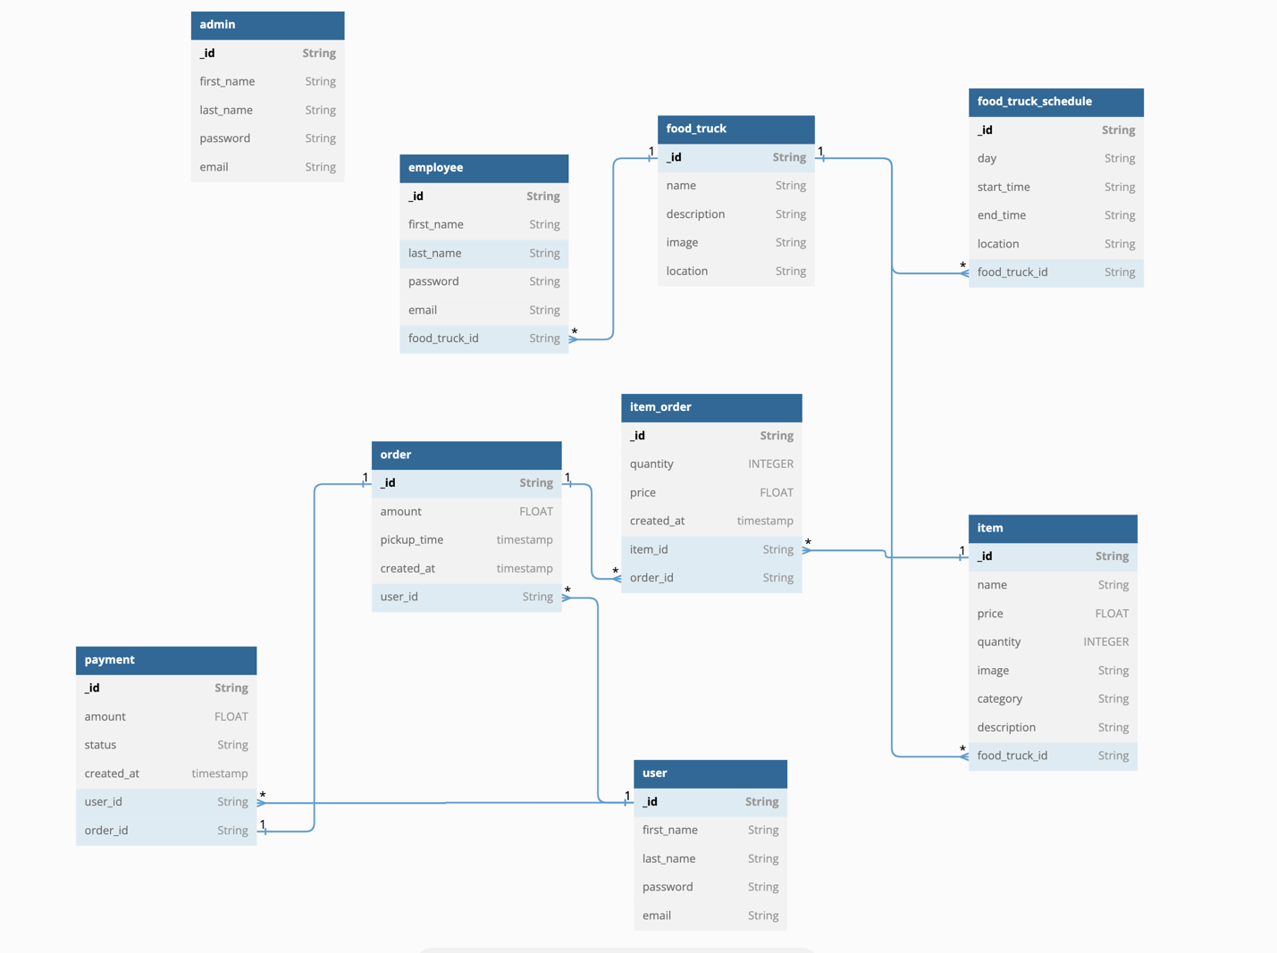

Sample Data

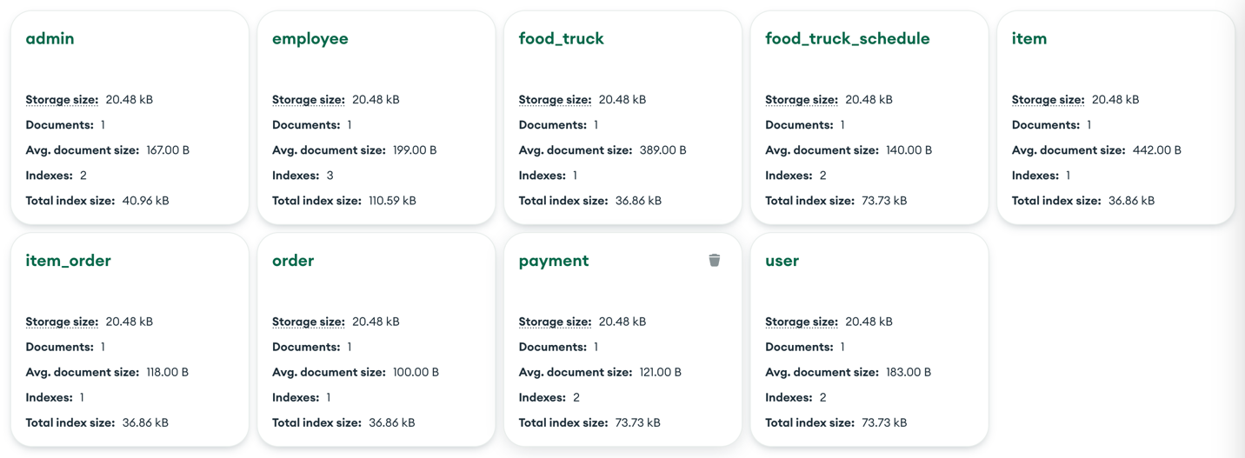

MongoDB Shell Commands
// Insert a user
db.user.insert({
firstName: "John",
lastName: "Doe",
passwordHash: "hashed_password",
email: "john.doe@example.com",
role: "CUSTOMER"
})

// Insert a food truck
db.food_truck.insert({
name: "Tasty Truck",
description: "Delicious street food",
image: "tasty_truck_image_url",
slug: "tasty-truck"
})

// Insert a food truck schedule
db.food_truck_schedule.insert({
day: "Monday",
startTime: ISODate("2023-05-02T08:00:00Z"),
endTime: ISODate("2023-05-02T16:00:00Z"),
food_truck_id: ObjectId("food_truck_object_id") // Replace with the actual ObjectId of the food truck
})

// Insert an item
db.item.insert({
name: "Burger",
description: "Juicy beef burger with cheese",
image: "burger_image_url",
slug: "burger",
price: 5.99,
quantity: 50,
restaurant_id: ObjectId("food_truck_object_id") // Replace with the actual ObjectId of the food truck
})

// Insert an order
db.order.insert({
createdAt: ISODate("2023-05-02T09:00:00Z"),
type: "PICKUP",
status: "PENDING",
user_id: ObjectId("user_object_id") // Replace with the actual ObjectId of the user
})

// Insert an invoice
db.invoice.insert({
createdAt: ISODate("2023-05-02T09:01:00Z"),
amount: 5.99,
paymentMethod: "CREDIT_CARD",
totalAmount: 5.99,
address: "123 Street, City, Country",
order_id: ObjectId("order_object_id") // Replace with the actual ObjectId of the order
})

// Insert an item order
db.item_order.insert({
quantity: 1,
item_id: ObjectId("item_object_id"), // Replace with the actual ObjectId of the item
order_id: ObjectId("order_object_id") // Replace with the actual ObjectId of the order
})

// Find all users
db.user.find()

// Find all food trucks
db.food_truck.find()

// Find all food truck schedules
db.food_truck_schedule.find()

// Find all items
db.item.find()

// Find all orders
db.order.find()

// Find all invoices
db.invoice.find()

// Find all item orders
db.item_order.find()

